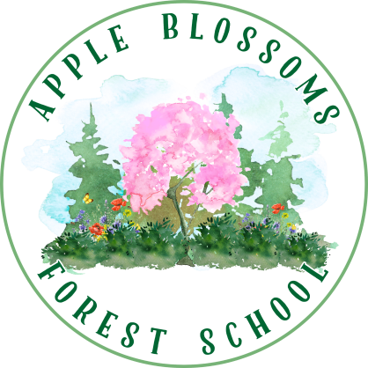
Apple Blossoms Forest School

Family Agreement
- Understand the benefits of outdoor play: We love that Apple
Blossoms Forest School is an immersive outdoor learning program! We encourage our child to explore nature in all seasons and habitats, including exploration in or near water, ice, snow, and mud. We welcome the benefits of children taking risks and encourage messy, active, whole-body play.
- Handbook & Safety Binder: We will carefully read our school handbook, including the Hazards and Benefits Binder.
- Program Calendar: We will review the calendar provided and join the Apple Blossoms Forest School Google Calendar to make note of important dates and days off.
- Gear: We will use winter/rain gear provided by ABFS for attendance at forest school, and follow the gear policies provided in the contract of care.

- Arrival: My child will arrive with all the proper gear for the day. Also I will arrive at my assigned time to eliminate congestion on the road and at the entrance of our school.
- Pick-Up: I will promptly pick-up my child at the assigned pick-up time. If another adult will be picking up my child I will be in contact with a teacher to notify them and have them listed as an approved adult on the in-case of emergency document.
- Illness: We don’t want staff or other children to get sick! We will keep our child home if they are ill with a fever, rash, contagious illness, or other discomfort that prevents full participation in vigorous outdoor play. See additional policies related to COVID-19.
- Foraging: Our child has permission to taste wild edibles such as wood sorrel, berries, mint leaves, etc. and other plants used for tea making and baking. Our school will guide children in foraging and use safe foraging practices.
- Tools and Fire-Making: We encourage our child to use real tools and participate in campfire activities and fire-making under the careful supervision of adults.
- Respect: We will work together to cultivate trust, respect, gratitude, and friendship in our learning community. We will always show respect to each other and the land we explore.

We are the parents/legal guardians of the child below and we agree to the policies set forth here.

Child’s Name (printed)

Parent/Legal Guardian (printed, signed, date)

Parent/Legal Guardian (printed, signed, date)

